Supplement file 4 Heat Maps of Different Expressed mRNAs and lncRNAs
mRNA:
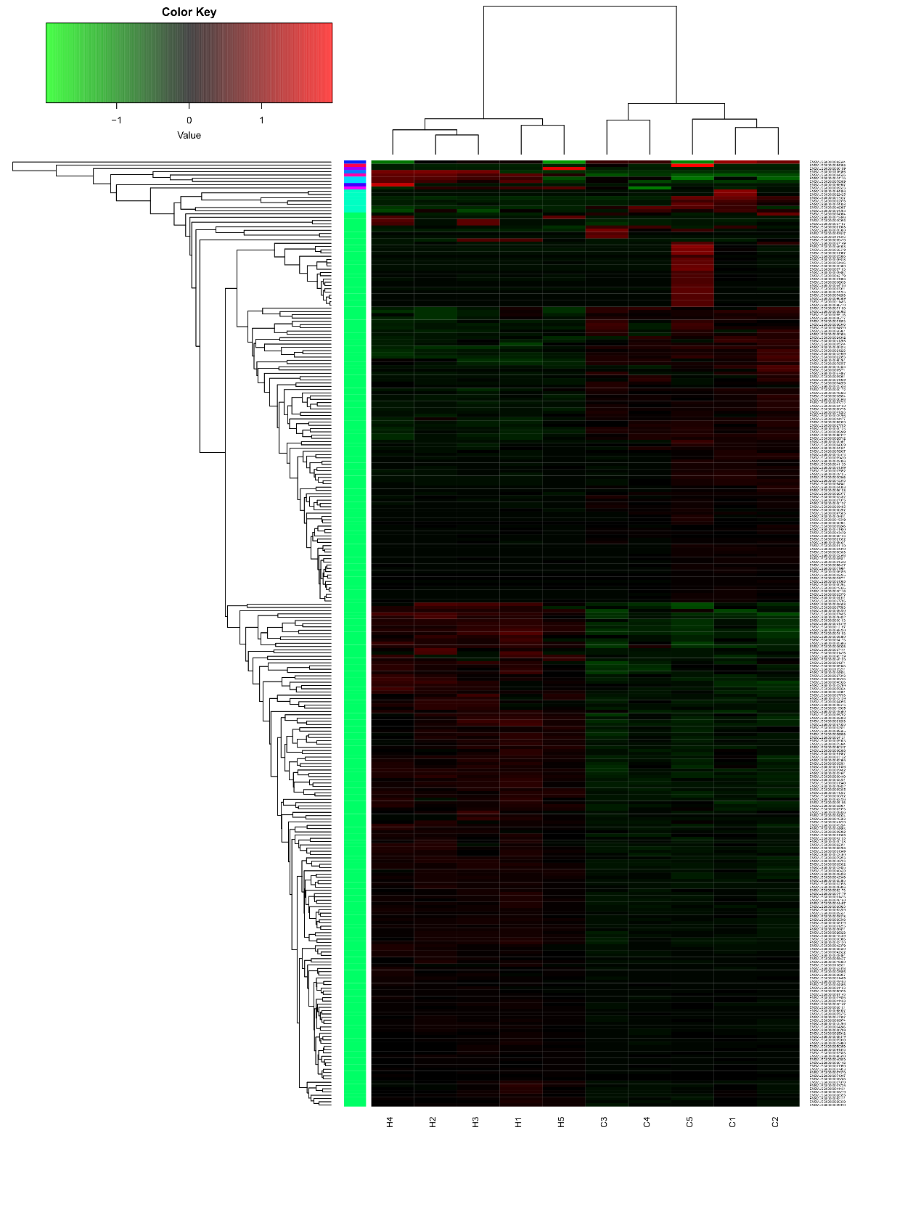

LncRNA
